**EPICK BIKES**

Task -1

**Problem Statement:** In the recent electric cycles, the battery level indicator does not have a proper resolution which makes the user confused about the battery level. We need to design this battery level indicator for the range 30-42 Volt.

**Solution**:

To improve resolution we decided to use a 10 LED bar display for battery (voltage) level indicator.

**Theoretical Procedure:**

1. We had 2 options to make the voltage level indicator - either using the Arduino (or any MCU) or directly using a 10 LED bar driver IC.
2. Based on space and cost constraints we decided to go with driver IC. The best option is LM3914 (as it is the most widely used 10 LED driver IC and available at low cost).
3. The datasheet of LM3914 was referred in <https://www.ti.com/lit/ds/symlink/lm3914.pdf>
4. The reference circuit for a 0-5V voltage level indicator given in the datasheet was implemented. This was followed by the implementation of a 0-12V voltage level indicator (as shown in the video - <https://youtu.be/s2I5IJomB3g> )  
   These circuits use a constant supply voltage for the V+ of the IC, which is not the case in our electric cycles.
5. LM3914 IC supply voltage should be less than 25 volts which is not a problem for 5 volt and 12 volt batteries . But when we need to implement the same with a 42 volt battery it is an issue so to avoid that we decide to use a voltage divider circuit such that only half the battery voltage is given to the IC.
6. The IC principally uses 3 pins - VHi, VLo and SIG.   
   The voltage supplied to the VHi pin must be equal to the upper limit of our battery voltage and that supplied to VLo must be equal to the lower limit of our battery voltage. The voltage of the battery must be given to the signal input (SIG) pin so that the voltage can be indicated.
7. *Using the internal voltage regulator to set the values of VHi and VLo* -   
   The pins 7 (reference out) and 8 (reference adjust), can be used like the output and adjust pins of any general voltage regulator to obtain a voltage from 1.25V to 1V less than V+ (by choosing the resistors R1 and R2 according to the following formula).  
   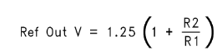 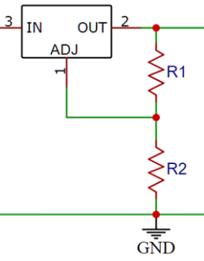  
   Here, on connecting VHi to pin 7 and VLo to pin 8, we can get the upper and lower limits within a range of 1.25V.  
     
   For a different range, we can use the pins 7 and 8 to obtain the upper limit voltage value (which has to be below the V+) and connect VHi to pin 7 and use a voltage divider or another constant voltage to give the lower limit voltage to VLo.  
     
   *Without using the internal voltage regulator -*   
   The upper and lower limit voltage values can directly be supplied to VHi and VLo pins directly from an external stable voltage source, without using the internal voltage regulator.
8. We learned that the resistor connected to pin 7 adjusts the brightness of the LED .
9. The lower and higher ranges of the battery must be set properly because these voltages only decide no.of LED’s to glow . So whatever be the Voltage of the battery the VLo (4 th) pin must be 15 Volt ( half of lower range voltage since we are using half voltage divider) and the VHi (6th) pin must be 21 volt ( half of higher range voltage since we are using half voltage divider) . We decided to use a component which can power the IC ( V+ i.e., 3rd pin) and also always set VLo and VHi pins to their respective voltages.
10. We decided to use 24 Volt zener diodes ( two 12 volt zener diodes ) as shown in figure below so that V+ is always 24 V and the VLo and VHi pins are set to their respective voltages using suitable voltage dividers.  
     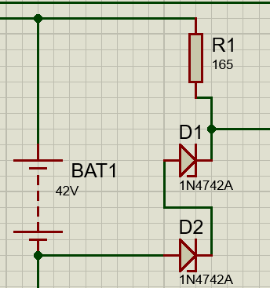

**Practical Procedure (In Controlytics):  
  
Phase 1**

The below circuit was made by Controlytics AI.   
The 12V zener diode provides the constant 12v voltage to V+ of the IC. The 56K and 100K potentiometer are used to make a voltage divider and scale down the battery limits from 42-30V to 3.9-2.75V.  
Here the internal voltage regulator was used to set the upper and lower voltage limits.

Drawbacks in this circuit - The circuit worked accurately in dot mode, but in bar mode, all the lights remained on irrespective of the voltage provided. The cause for this behaviour was unknown.

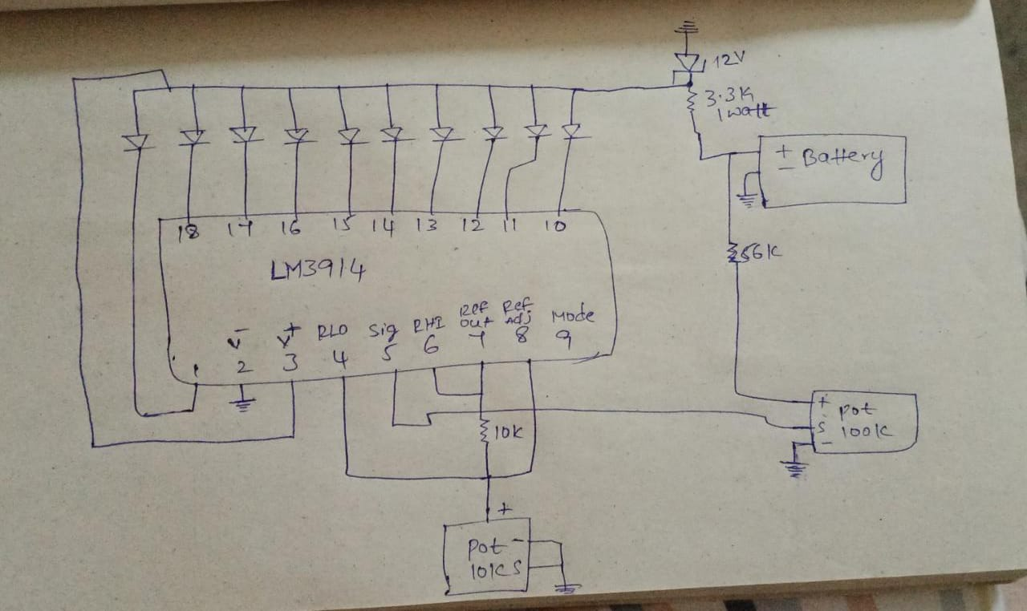

**Phase 2**

This phase is about completely working with the IC . From the website <https://electronics.stackexchange.com/questions/127639/can-someone-explain-what-each-pin-does-on-an-lm3914-dot-bar-graph-chip> it is said that the voltage at 7 th pin will be 1.25 volt greater than the 8 pin .   
When pin 8 is grounded, 1.25V output is obtained at pin 7.  
It was observed on 19/6/23 in the Epick bikes office that when pin 8 is not connected, then the voltage at pin 7 is around 0.5-1V less than the V+ and pin 8 is showing 1.25 V less than pin 7. The reason was not known .  
Hence, in the next circuit the pin 8 was left unconnected, VHi was connected to pin 7 and VLo was connected to a voltage divider from VHi to get the lower limit voltage.  
Also, two 12V zener diodes were used to provide constant voltage supply (refer point 10 in Theoretical procedure) and the signal voltage was given from a voltage divider (refer point 10 in Theoretical procedure)  
  
Drawbacks of this circuit - The voltage at pin 7 was not approximately the same as the voltage at V+.  
  
**Phase 3**

This phase doesn’t use the internal voltage regulator of the IC. The 24V voltage drop obtained across the zener diodes was used to provide a constant voltage to both the V+and the VHi pins. A voltage divider from VHi was used to obtain a voltage in the range of 14-15V at the VLo pin and the voltage to the signal pin was provided through the voltage divider same as in phase 2.  
A resistance of 3.3K ohms was connected in series to the zener diodes here.  
  
Drawbacks of the circuit - Upon connecting the IC circuit (the load) across the zener diodes, the voltage across the diodes was dropping from 24V to 1.6V, as a result the series resistor was also getting heated up immensely. This couldn’t be rectified even after using higher values of resistances. The reason may be the higher current flow .  
  
**Phase 4**

On reducing the value of the series resistor (by connecting another 3.3K ohms resistor in parallel to it) the heating of the resistors reduced (as the current got divided) and there was relatively lesser voltage drop across the zener diodes.  
Upon further reducing the resistance, the voltage across the zener diodes finally remained at 24V even under load, when two 330 ohm 1W resistors connected in parallel were used in series with the zener diodes.  
  
The VHi pin was connected to V+ pin here through a 10K ohms resistor to get a slight voltage drop from the V+ value and get approximately 21-22V at VHi.  
  
Also, the pin 7 was grounded through a 3.3K ohms resistor for controlling the led intensity and the pin 8 was grounded.  
  
A voltage divider circuit was used to obtain 14-15V from the 22V coming out from the VHi pin. The voltage divider used a 3K (i.e., two 1.5K) and a 4.5K (i.e., two 1.5K) ohms resistors to get the necessary voltage.  
  
Drawbacks of the circuit - The 330 ohms resistors were still getting heated up. The proposed solution was to use resistors with higher wattage rating.